



Nottingham Works Programme: Nottingham Apprenticeship Grant (NAG)

Frequently Asked Questions

1. What is the Nottingham Works Programme?

The Nottingham Works Programme consists of six related activities designed to help unemployed and economically inactive young people in Nottingham to progress in education, training and employment opportunities.

The Nottingham Works Programme is part-financed by Nottingham City Council and the European Union through the European Social Fund and the Youth Employment Initiative (YEI). ESIF supports activities to extend employment opportunities and develop a skilled workforce.

2. What is the Nottingham Apprenticeship Grant?

The Nottingham Apprenticeship Grant is one of the six activities in the City Council’s Nottingham Works programme.

Employers can access a Nottingham Apprenticeship Grant of £1,000 if they take on an unemployed or economically inactive 16-24 year old City resident on as an apprentice.

3. Which Companies are eligible?
Any organisation based in Nottingham City Council’s boundary or within reasonable travel time or distance of the city, which employs less than 1,000 employees.

4. Which Apprenticeships are eligible?
To qualify the apprentice must:
- start their Apprenticeship within four weeks of the start of their contract of employment with the company.
- be on a recognised Apprenticeship Framework or Standard
- have the potential to become a sustainable job after the Apprenticeship has been achieved.

5. Which young people are eligible?
- Nottingham City residents aged between 16 and 24 year on the date they start their Apprenticeship
- Persons who are unemployed or economically inactive prior to starting their Apprenticeship

6. What Apprenticeships/companies are excluded?

- Companies which employ more than 1,000 employees

- Apprenticeships which have a start date prior to 1st April 2016.

- Apprenticeships which have a start date after 1st January 2018.

- Companies which have exceeded the State Aid De Minimis threshold for European Funding.

- Companies that are planning redundancies.

- Where firms have other amounts owing to Nottingham City Council, this may be taken into consideration in determining eligibility.

- New positions which companies are obliged to create as a result of a community benefits clause in a contract with Nottingham City Council are excluded.

7. At what point is the Grant paid? What if an apprentice leaves after this?

The Grant is payable 13 weeks after the start date of the Apprenticeship. Confirmation that the apprentice is still participating on the programme and attending work and training regularly will be confirmed by the Apprenticeship Training Provider on this date.

If the apprentice subsequently leaves the employer will not be asked to pay back the Grant.

8. What is the closing date?

The total funds available are limited; therefore the scheme will operate until such time as its resources are fully committed or until 31st March 2018 (whichever is soonest)

9. What about large applications?

Applications for multiple apprentices are welcome; however, applications concerning more than 5 Apprenticeships will require additional information to be provided. Such applications may also be subject to special terms and conditions.

10. What checks are made after the grant is approved?

The Nottingham Works team will contact the apprentice’s employer six months after the grant has been paid to get an update on the apprentice’s employment status.

At a later date, employers may also be asked to provide information on the destination of the apprentice after they have completed their Apprenticeship.

The Council reserves the right to require production of records relating to the recruitment and payment of the apprentices involved.

11. Who will administer the Nottingham Apprenticeship Grant?

The Nottingham Apprenticeship Grant will be administered wholly by Nottingham City Council.

In special circumstances, and in furthering the aims of the scheme, the Council reserves the right to delegate authority to approved agencies in respect of certain aspects of administration of the Nottingham Apprenticeship Grant.

12. Can employers claim this grant in addition to Nottingham Jobs Fund and NAS’ AGE grant?

Yes, employers may also be eligible to receive financial support from the Nottingham Jobs Fund and the Apprenticeship Grant for Employers (AGE grant) if they meet the eligibility rules for these schemes.

Employers accessing the enhanced Nottingham Jobs Fund Plus scheme will not be eligible to also claim the Nottingham Apprenticeship Grant.

13. Will the information provided be used for any other purpose?

The Council reserves the right to report the number of apprentices recruited and the amount of grant awarded and paid to each recipient company to relevant City Council Committees, the full Council, the National Apprenticeship Service and The Department for Work & Pensions in line with the requirements of Nottingham City Council’s agreement with the ESF Managing Authority and in any publicity about Nottingham Works Programme or the Nottingham Apprenticeship Grant. This information may also be subject to freedom of information requests.

14. How do I apply?

You can request the application forms for this grant by e-mailing
jobs.hub@nottinghamcity.gov.uk or nottinghamjobsfund@nottinghamcity.gov.uk

15. Please Note:
The Council reserves the right to refuse grant or seek repayment of grant paid in the event that an applicant:-

- fails to comply with any of the conditions stated in the foregoing sections

- fails to disclose information relevant to their grant application

- provides information which is misleading or incorrect

- the Council reserves the right to reject any application for the Nottingham Apprenticeship Grant which it deems to be inappropriate

Appendix A: Nottingham City Council boundaries within which apprentice must be resident
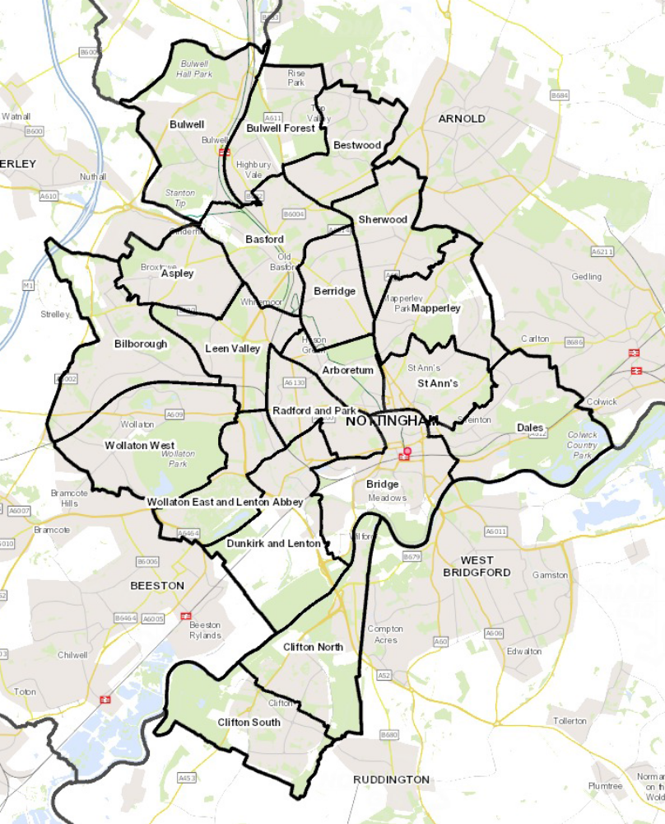

Economically inactive refers to a young person who is not seeking work or unavailable to start work
See Appendix A for Nottingham City Council boundaries within which apprentices must be resident

